## Merchant

Demo date: Feb 12, 2025  
Scoping start date:

MSA Signature Date: Feb 26, 2025  
Onboarding Kick Off Date: Mar 3, 2025

[If Exists] Opt-Out Date: NONE  
Go Live Date:

GTM POC: Paula  
Implementation POC: JeffJean

ERP: QBO

Tax Integration: No Tax

### 

### Key people at Merchant

### Accountant:

### CFO: Nicole <https://www.linkedin.com/in/nicolebjordan5>

### Customer service rep who is really involved:

* Account Receivable POC
* Billing POC

### Etc.

### 

| Notes Sections [Ops International Team to Ignore] *(AE/ Implementation to fill)*   * Info on how merchant bills   + Flat SaaS   + Changing payment terms (could happen mid-contract) * Is there any important merchant relationship information? Nicole is the consultant CFO  1) What is the merchant temperament?   So nice, she loves Tabs and totally aligns with our vision  2) Is there a key POC: (i.e.: who is the buyer/decision maker?)  Nicole does it all 3) What are the Tabs features that the key POC cares about?   1. Auto invoice creation + sending of invoices 2. Dunning + collections workflow 3. Rev rec and reporting 4. Renewal data + dash 5. Tabs → Hubspot data |
| --- |

### 

### Company summary *(AE to fill)*

Summary of what company does:  
Instil is a cloud-based donor management platform designed to help nonprofit organizations streamline their operations and enhance their impact

Goals (North star)  
*(AE/ Implementation to fill)*

What is the merchant's goal? What pain are we solving? Why are they buying Tabs?  
Pain:  
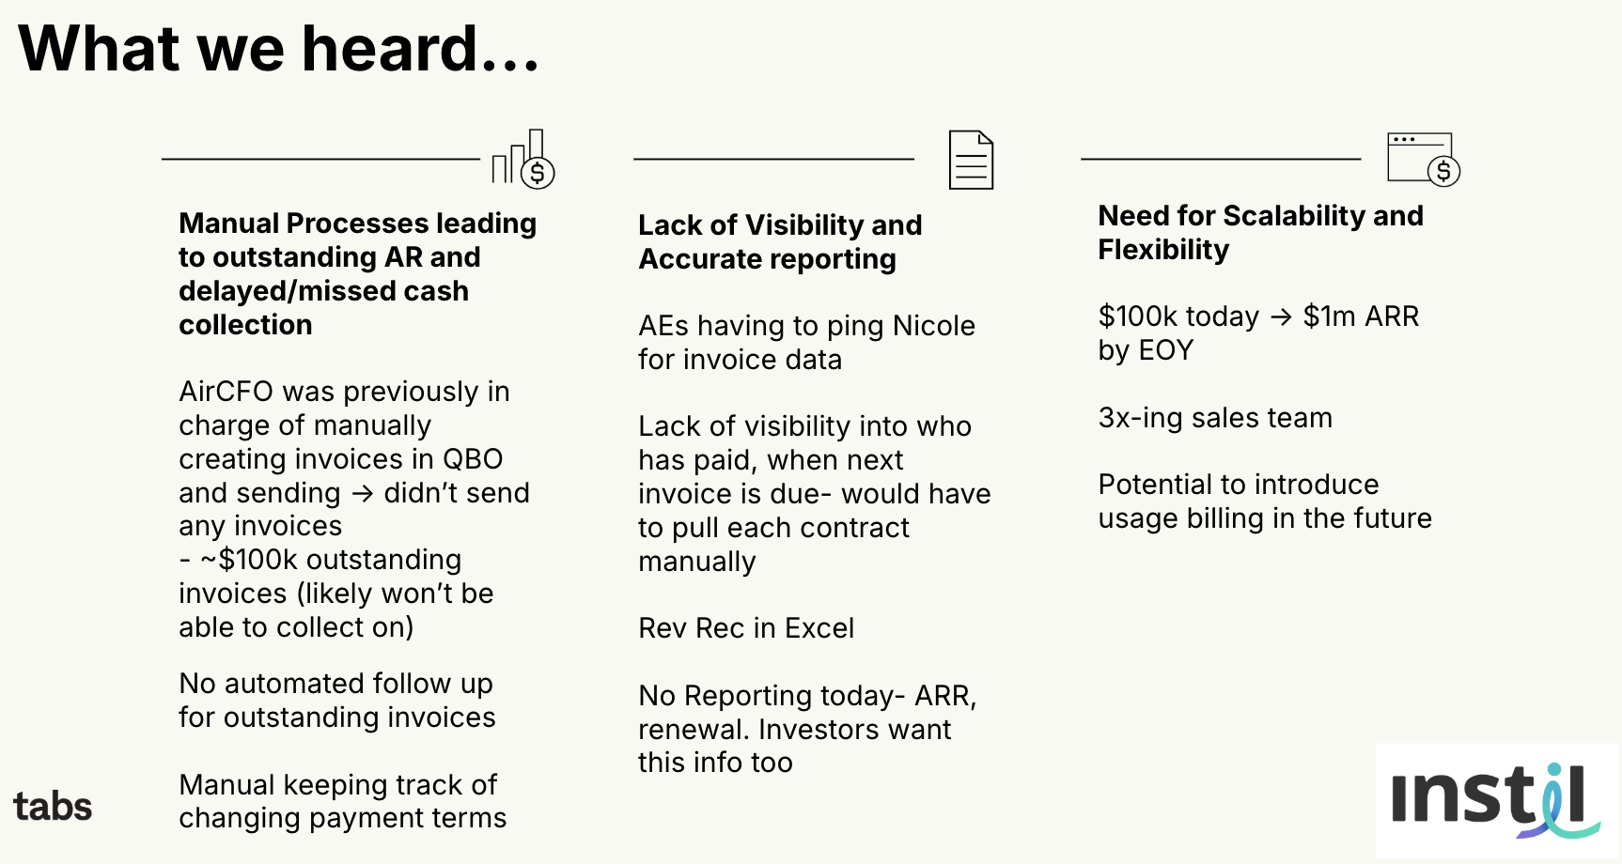

Goals:  
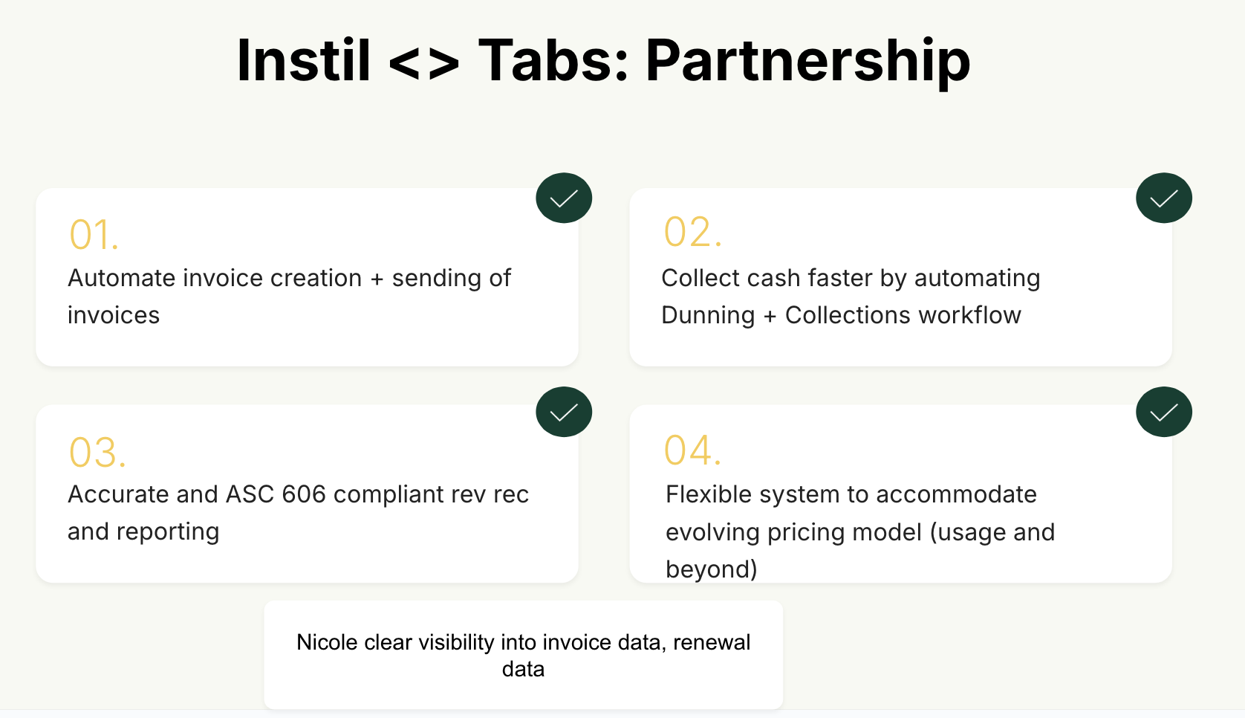

Is there an opt out clause? If so, what is the merchant looking for so they do not exercise it?

No

### Billing model *(AE/ Implementation to fill)*

* Are there unique things about the customer creation process for this merchant?  
  Hubspot integration
* Information on how merchant bills
* How contract is broken up
* One off things to know about the merchant

Had some concerns around their hubspot set up. There will need to be custom scoping done to understand what data they want to pull from Hubspot → Tabs. This is critical for them so that their sales people can see invoice data.

### Contract Processing Steps *(Implementation/Success to fill)*

1. Steps to process
   1. Service Start Date: Locate the "Start Date" mentioned under Initial Service Term.
   2. Months of Service: Identify the initial service term, which is usually specified in months (e.g., 36 months).
   3. Item Name: Find the name of the service being provided, such as "Cloud-based constituent relationship management solution."
      1. **Call line item for software charges "Software Fees" and map to item "Software Fees" (do not use name in Services)**
      2. Default to “Service Fees” if none available
   4. Item Description: Leave blank.
   5. Integration Item: Leave blank.
   6. Billing Type: Usually Flat.
   7. Total Price: Identify the total service fee.
      1. **Do not include $0 implementation fees**
      2. **Put discount in line, not own line item**
   8. Quantity: Check for any references to the number of licenses, users, or other units applicable to the contract.
   9. Start Date: Service start date.
   10. Periods: Confirm through the term.
   11. Frequency: Identify the invoicing schedule (e.g., annually, upon contract anniversary, or milestone-based).
   12. Payment Terms: Check under Section 4 Payment of Fees
   13. **Net Terms: If the contract says pay in advance, use net 0.**
   14. **Renewal: If section 5.1 in contract states auto-renewal (see screenshot) process as flat renewal for one year beyond initial contract term**
2. Anything to ignore in contracts?
3. Specifics processing things the merchant has requested that may differ by contract (e.g. always back-date invoice date to final day of the month)
4. Default Service Term
   1. If None Listed, Ops Default is 1 Year
5. Default Net Payment Terms
   1. If None, Ops Default is 30
6. Default Billing Frequency
   1. If None Listed, Ops Default is Monthly
7. How do we handle taxes as a line item?
   1. If None Listed, Ops Default is every tax line item becomes a BT

### Events Processing (if necessary) *(Implementation/Success to fill)*

* Any important information on events billing

Integration Items Processing (if necessary)  
*(Implementation/Success to fill)*

* What are the instructions for assigning integration items?
* Example: All Statsig integrations items should be labeled as “Sales”
* Example: All “Pinata” integration items should be labeled as “Software Subscription Bundle” unless otherwise noted by Merchant

Post Processing Communications (if necessary)  
*(Implementation/Success to fill)*

* Does the Ops Team need to notify anyone on the team re: completion of processing batches in Implementation or Active phase?
* Who needs to be notified and when?
  + Example:
    - Who: Customer Success [Azmat Aziz] needs to be notified
    - Where: Messari internal merchant channel
    - When: contracts are processed [Merchant Phase: Active]

### Customer Information *(Implementation/Success to fill)*

* Any important information on specifics customers of this merchant
  + Special memo’s certain invoices require
  + Invoice changes due to merchant/customer relationship

### Feature Requests *(AE/Implementation/Success to fill)*

* FR 1
  + What is it
  + Why it's important
  + Urgency

### Rewatch Calls *(AE/Implementation/Success to fill)*

* Rewatch by dates   
    
  <https://us-56595.app.gong.io/call?id=6717105563477126301&account-id=4632005772074296398>   
  <https://us-56595.app.gong.io/call?id=5230608562195243038&account-id=4632005772074296398>  
  <https://us-56595.app.gong.io/call?id=3892700273853143293&account-id=4632005772074296398>